UNITED STATES
SECURITIES AND EXCHANGE COMMISSION
Washington, D.C. 20549

FORM 8-K
Current Report

Pursuant to Section 13 or 15(d) of the Securities Exchange Act of 1934

Date of Report (date of earliest event reported): August 6, 2026

IOVANCE BIOTHERAPEUTICS, INC.
(Exact Name of Registrant as Specified in Charter)

Delaware
(State of Incorporation)
001-36860 |  | 75-3254381
Commission File Number |  | (I.R.S. Employer Identification No.)
825 Industrial Road, Suite 100
San Carlos, California |  | 94070
(Address of Principal Executive Offices) |  | (Zip Code)
(650) 260-7120
(Registrant’s Telephone Number, Including Area Code)
Check the appropriate box below if the Form 8-K filing is intended to simultaneously satisfy the filing obligation of the registrant under any of the following provisions:

 | ☐ | Written communications pursuant to Rule 425 under the Securities Act (17 CFR 230.425).

 | ☐ | Soliciting material pursuant to Rule 14a-12 under the Exchange Act (17 CFR 240.14a-12).

 | ☐ | Pre-commencement communications pursuant to Rule 14d-2(b) under the Exchange Act (17 CFR 240.14d-2(b)).

 | ☐ | Pre-commencement communications pursuant to Rule 13e-4(c) under the Exchange Act (17 CFR 240.13e-4(c)).

Indicate by check mark whether the registrant is an emerging growth company as defined in as defined in Rule 405 of the Securities Act of 1933 (§230.405 of this chapter) or Rule 12b-2 of the Securities Exchange Act of 1934 (§240.12b-2 of this chapter). Emerging growth company ☐

If an emerging growth company, indicate by check mark if the registrant has elected not to use the extended transition period for complying with any new or revised financial accounting standards provided pursuant to Section 13(a) of the Exchange Act. ☐

Securities registered pursuant to Section 12(b) of the Act:

Title of each class | Trading  Symbol(s) | Name of each exchange on which  registered
Common stock, par value $0.000041666 per value | IOVA | The Nasdaq Stock Market, LLC

Item 8.01 | Other Events.

On August 6, 2026, Iovance Biotherapeutics, Inc. (the “Company”) updated its corporate presentation that it uses for presentations at healthcare conferences and to analysts, current stockholders, and others. A copy of the Company’s presentation that it intends to use at such events is attached as Exhibit 99.1 and is incorporated herein by reference.

Item 9.01 | Financial Statements and Exhibits.

(d) Exhibits.

Exhibit  No. |  | Description
99.1 |  | Iovance Biotherapeutics, Inc., Corporate Presentation – August 2026
104 |  | Cover Page Interactive Data File (embedded as Inline XBRL document)

SIGNATURES

Pursuant to the requirements of the Securities Exchange Act of 1934, the Registrant has duly caused this Report to be signed on its behalf by the undersigned hereunto duly authorized.

Date: August 6, 2026 | Iovance Biotherapeutics, Inc.
 | By: | /s/ Frederick G. Vogt
 |  | Name: | Frederick G. Vogt, Ph.D., J.D.
 |  | Title: | Interim CEO and President, and General Counsel

Exhibit 99.1
 |  | 1 © 2026, Iovance Biotherapeutics, Inc. Corporate Overview August 2026 1
 | 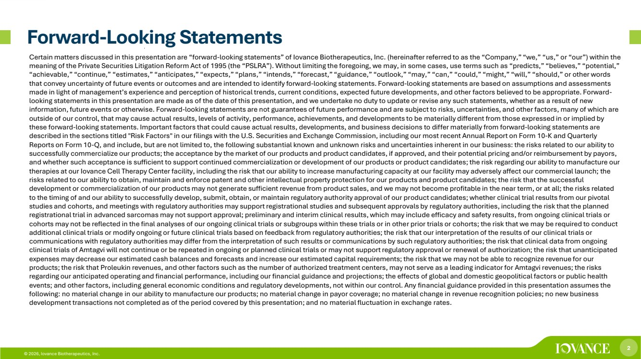 | 2 © 2026, Iovance Biotherapeutics, Inc. Forward-Looking Statements Certain matters discussed in this presentation are “forward-looking statements” of Iovance Biotherapeutics, Inc. (hereinafter referred to as the “Company,” “we,” “us,” or “our”) within the meaning of the Private Securities Litigation Reform Act of 1995 (the “PSLRA”). Without limiting the foregoing, we may, in some cases, use terms such as “predicts,” “believes,” “potential,” “achievable,” “continue,” “estimates,” “anticipates,” “expects,” “plans,” “intends,” “forecast,” “guidance,” “outlook,” “may,” “can,” “could,” “might,” “will,” “should,” or other words that convey uncertainty of future events or outcomes and are intended to identify forward-looking statements. Forward-looking statements are based on assumptions and assessments made in light of management’s experience and perception of historical trends, current conditions, expected future developments, and other factors believed to be appropriate. Forward-looking statements in this presentation are made as of the date of this presentation, and we undertake no duty to update or revise any such statements, whether as a result of new information, future events or otherwise. Forward-looking statements are not guarantees of future performance and are subject to risks, uncertainties, and other factors, many of which are outside of our control, that may cause actual results, levels of activity, performance, achievements, and developments to be materially different from those expressed in or implied by these forward-looking statements. Important factors that could cause actual results, developments, and business decisions to differ materially from forward-looking statements are described in the sections titled "Risk Factors" in our filings with the U.S. Securities and Exchange Commission, including our most recent Annual Report on Form 10-K and Quarterly Reports on Form 10-Q, and include, but are not limited to, the following substantial known and unknown risks and uncertainties inherent in our business: the risks related to our ability to successfully commercialize our products; the acceptance by the market of our products and product candidates, if approved, and their potential pricing and/or reimbursement by payors, and whether such acceptance is sufficient to support continued commercialization or development of our products or product candidates; the risk regarding our ability to manufacture our therapies at our Iovance Cell Therapy Center facility, including the risk that our ability to increase manufacturing capacity at our facility may adversely affect our commercial launch; the risks related to our ability to obtain, maintain and enforce patent and other intellectual property protection for our products and product candidates; the risk that the successful development or commercialization of our products may not generate sufficient revenue from product sales, and we may not become profitable in the near term, or at all; the risks related to the timing of and our ability to successfully develop, submit, obtain, or maintain regulatory authority approval of our product candidates; whether clinical trial results from our pivotal studies and cohorts, and meetings with regulatory authorities may support registrational studies and subsequent approvals by regulatory authorities, including the risk that the planned registrational trial in advanced sarcomas may not support approval; preliminary and interim clinical results, which may include efficacy and safety results, from ongoing clinical trials or cohorts may not be reflected in the final analyses of our ongoing clinical trials or subgroups within these trials or in other prior trials or cohorts; the risk that we may be required to conduct additional clinical trials or modify ongoing or future clinical trials based on feedback from regulatory authorities; the risk that our interpretation of the results of our clinical trials or communications with regulatory authorities may differ from the interpretation of such results or communications by such regulatory authorities; the risk that clinical data from ongoing clinical trials of Amtagvi will not continue or be repeated in ongoing or planned clinical trials or may not support regulatory approval or renewal of authorization; the risk that unanticipated expenses may decrease our estimated cash balances and forecasts and increase our estimated capital requirements; the risk that we may not be able to recognize revenue for our products; the risk that Proleukin revenues, and other factors such as the number of authorized treatment centers, may not serve as a leading indicator for Amtagvi revenues; the risks regarding our anticipated operating and financial performance, including our financial guidance and projections; the effects of global and domestic geopolitical factors or public health events; and other factors, including general economic conditions and regulatory developments, not within our control. Any financial guidance provided in this presentation assumes the following: no material change in our ability to manufacture our products; no material change in payor coverage; no material change in revenue recognition policies; no new business development transactions not completed as of the period covered by this presentation; and no material fluctuation in exchange rates.
 | 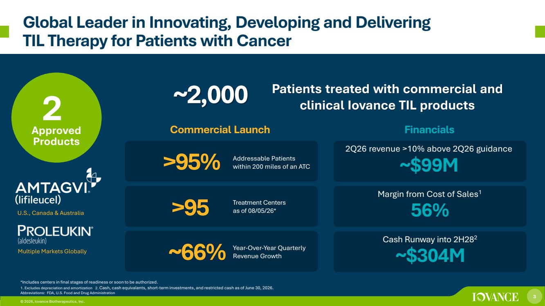 | 3 © 2026, Iovance Biotherapeutics, Inc. Global Leader in Innovating, Developing and Delivering TIL Therapy for Patients with Cancer Approved Products Commercial Launch Financials >95 Treatment Centers as of 08/05/26* 2 >95% Margin from Cost of Sales1 56% © 2026, Iovance Biotherapeutics, Inc. *Includes centers in final stages of readiness or soon to be authorized. 1. Excludes depreciation and amortization 2. Cash, cash equivalents, short-term investments, and restricted cash as of June 30, 2026. Abbreviations: FDA, U.S. Food and Drug Administration ~2,000 Patients treated with commercial and clinical Iovance TIL products U.S., Canada & Australia Multiple Markets Globally ~66% Addressable Patients within 200 miles of an ATC Year-Over-Year Quarterly Revenue Growth Cash Runway into 2H282 ~$304M 2Q26 revenue >10% above 2Q26 guidance ~$99M
 | 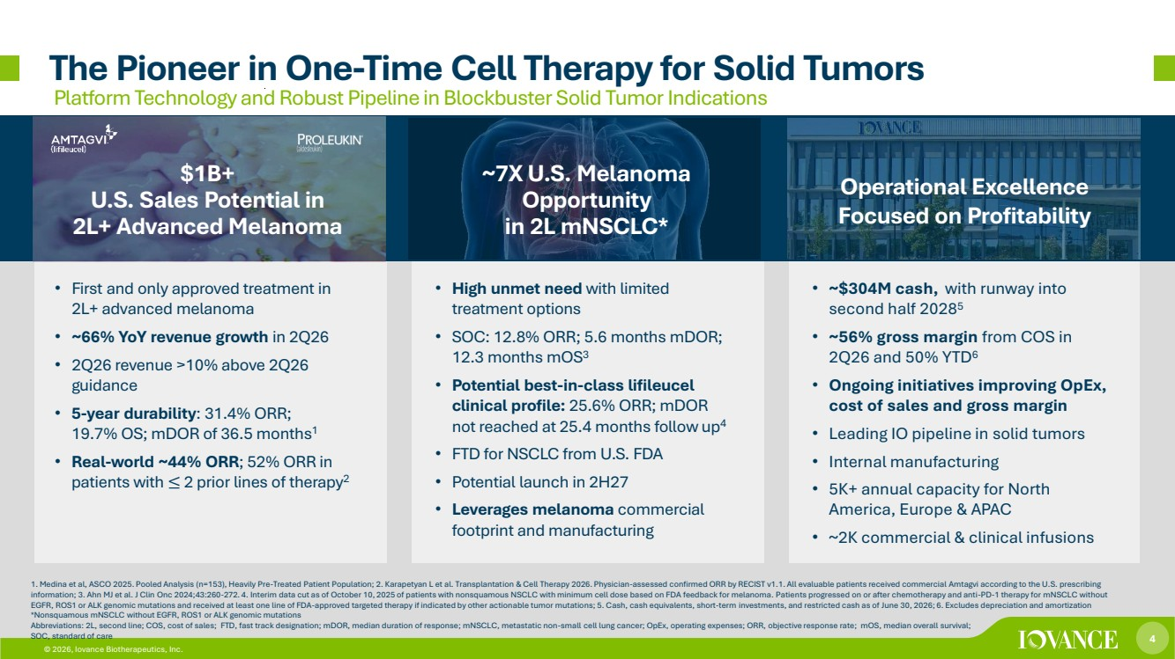 | 4 © 2026, Iovance Biotherapeutics, Inc. The Pioneer in One-Time Cell Therapy for Solid Tumors © 2026, Iovance Biotherapeutics, Inc. 1. Medina et al, ASCO 2025. Pooled Analysis (n=153), Heavily Pre-Treated Patient Population; 2. Karapetyan L et al. Transplantation & Cell Therapy 2026. Physician-assessed confirmed ORR by RECIST v1.1. All evaluable patients received commercial Amtagvi according to the U.S. prescribing information; 3. Ahn MJ et al. J Clin Onc 2024;43:260-272. 4. Interim data cut as of October 10, 2025 of patients with nonsquamous NSCLC with minimum cell dose based on FDA feedback for melanoma. Patients progressed on or after chemotherapy and anti-PD-1 therapy for mNSCLC without EGFR, ROS1 or ALK genomic mutations and received at least one line of FDA-approved targeted therapy if indicated by other actionable tumor mutations; 5. Cash, cash equivalents, short-term investments, and restricted cash as of June 30, 2026; 6. Excludes depreciation and amortization *Nonsquamous mNSCLC without EGFR, ROS1 or ALK genomic mutations Abbreviations: 2L, second line; COS, cost of sales; FTD, fast track designation; mDOR, median duration of response; mNSCLC, metastatic non-small cell lung cancer; OpEx, operating expenses; ORR, objective response rate; mOS, median overall survival; SOC, standard of care Platform Technology and Robust Pipeline in Blockbuster Solid Tumor Indications $1B+ U.S. Sales Potential in 2L+ Advanced Melanoma ~7X U.S. Melanoma Opportunity in 2L mNSCLC* Operational Excellence Focused on Profitability • First and only approved treatment in 2L+ advanced melanoma • ~66% YoY revenue growth in 2Q26 • 2Q26 revenue >10% above 2Q26 guidance • 5-year durability: 31.4% ORR; 19.7% OS; mDOR of 36.5 months1 • Real-world ~44% ORR; 52% ORR in patients with ≤ 2 prior lines of therapy2 • High unmet need with limited treatment options • SOC: 12.8% ORR; 5.6 months mDOR; 12.3 months mOS3 • Potential best-in-class lifileucel clinical profile: 25.6% ORR; mDOR not reached at 25.4 months follow up4 • FTD for NSCLC from U.S. FDA • Potential launch in 2H27 • Leverages melanoma commercial footprint and manufacturing • ~$304M cash, with runway into second half 20285 • ~56% gross margin from COS in 2Q26 and 50% YTD6 • Ongoing initiatives improving OpEx, cost of sales and gross margin • Leading IO pipeline in solid tumors • Internal manufacturing • 5K+ annual capacity for North America, Europe & APAC • ~2K commercial & clinical infusions
 | 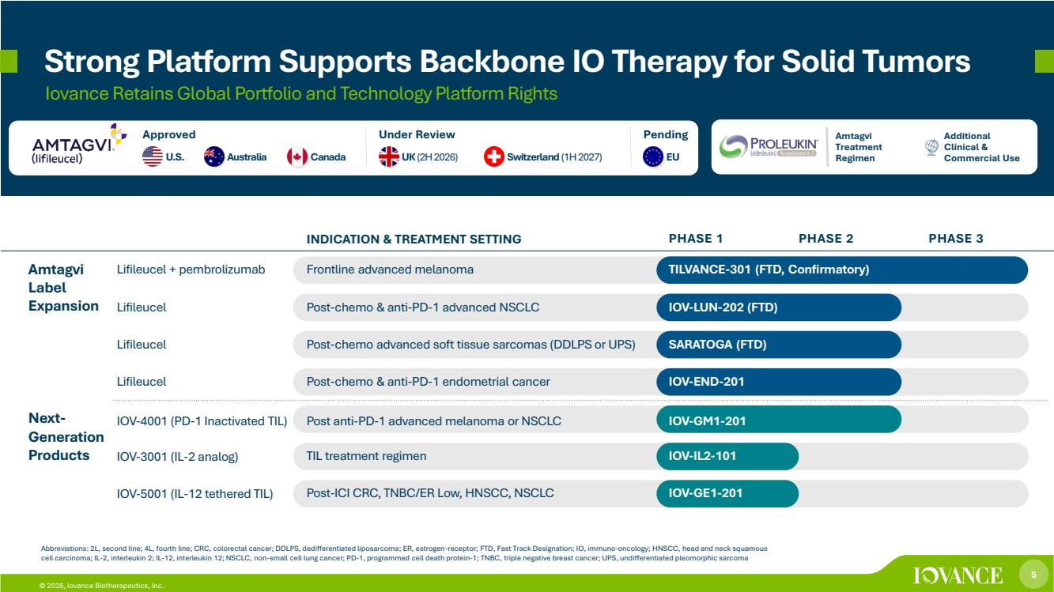 | 5 © 2026, Iovance Biotherapeutics, Inc. Strong Platform Supports Backbone IO Therapy for Solid Tumors Iovance Retains Global Portfolio and Technology Platform Rights Abbreviations: 2L, second line; 4L, fourth line; CRC, colorectal cancer; DDLPS, dedifferentiated liposarcoma; ER, estrogen-receptor; FTD, Fast Track Designation; IO, immuno-oncology; HNSCC, head and neck squamous cell carcinoma; IL-2, interleukin 2; IL-12, interleukin 12; NSCLC, non-small cell lung cancer; PD-1, programmed cell death protein-1; TNBC, triple negative breast cancer; UPS, undifferentiated pleomorphic sarcoma Approved Amtagvi Treatment U.S. Australia Canada UK (2H 2026) Switzerland(1H 2027) EU Regimen Additional Clinical & Commercial Use Under Review Pending INDICATION & TREATMENT SETTING PHASE 1 PHASE 2 PHASE 3 Amtagvi Label Expansion Lifileucel + pembrolizumab Frontline advanced melanoma TILVANCE-301 (FTD, Confirmatory) Lifileucel Post-chemo & anti-PD-1 advanced NSCLC IOV-LUN-202 (FTD) Lifileucel Post-chemo advanced soft tissue sarcomas (DDLPS or UPS) SARATOGA (FTD) Lifileucel Post-chemo & anti-PD-1 endometrial cancer IOV-END-201 Next-Generation Products IOV-4001 (PD-1 Inactivated TIL) Post anti-PD-1 advanced melanoma or NSCLC IOV-GM1-201 IOV-3001 (IL-2 analog) TIL treatment regimen IOV-IL2-101 IOV-5001 (IL-12 tethered TIL) Post-ICI CRC, TNBC/ER Low, HNSCC, NSCLC IOV-GE1-201
 | 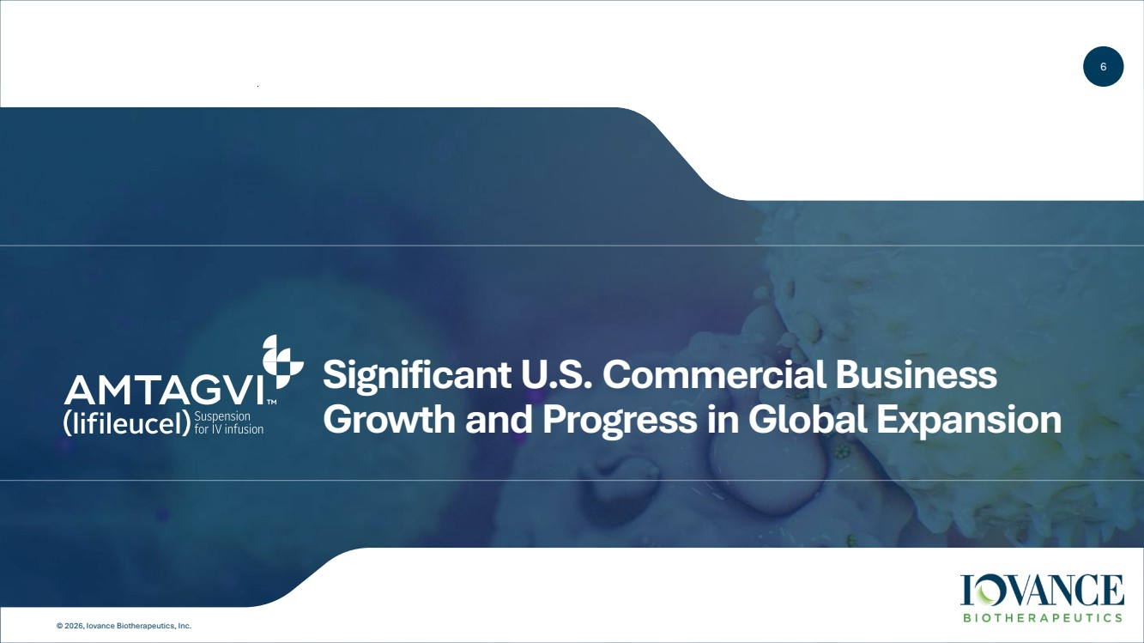 | 6 © 2026, Iovance Biotherapeutics, Inc. Significant U.S. Commercial Business Growth and Progress in Global Expansion
 | 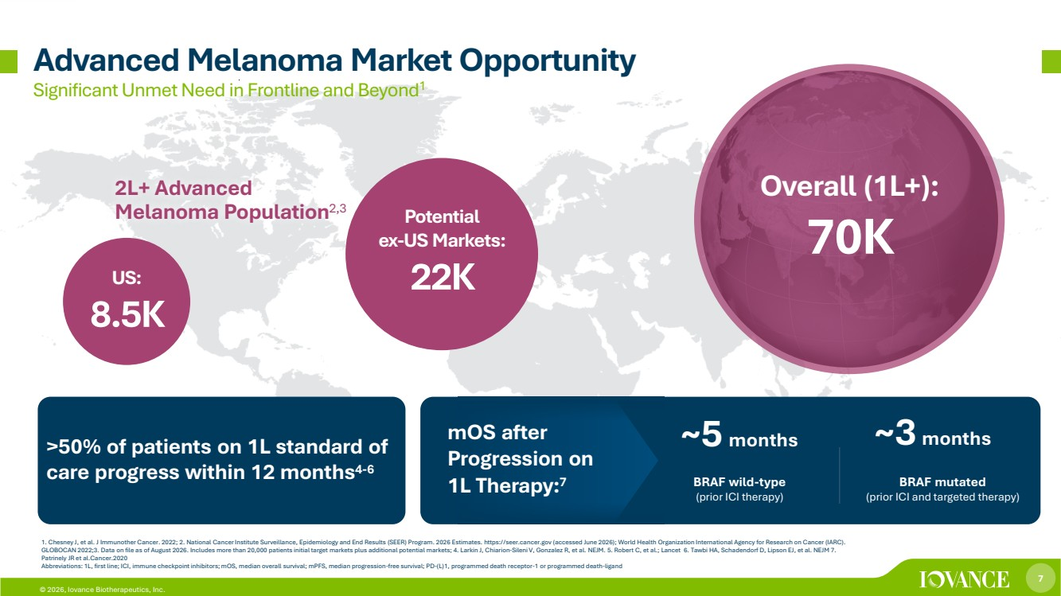 | 7 © 2026, Iovance Biotherapeutics, Inc. Significant Unmet Need in Frontline and Beyond1 Advanced Melanoma Market Opportunity 2L+ Advanced Melanoma Population2,3 US: 8.5K Potential ex-US Markets: 22K Overall (1L+): 70K BRAF wild-type (prior ICI therapy) ~5 months BRAF mutated (prior ICI and targeted therapy) ~3 months 1. Chesney J, et al. J Immunother Cancer. 2022; 2. National Cancer Institute Surveillance, Epidemiology and End Results (SEER) Program. 2026 Estimates. https://seer.cancer.gov (accessed June 2026); World Health Organization International Agency for Research on Cancer (IARC). GLOBOCAN 2022;3. Data on file as of August 2026. Includes more than 20,000 patients initial target markets plus additional potential markets; 4. Larkin J, Chiarion-Sileni V, Gonzalez R, et al. NEJM. 5. Robert C, et al.; Lancet 6. Tawbi HA, Schadendorf D, Lipson EJ, et al. NEJM 7. Patrinely JR et al.Cancer.2020 Abbreviations: 1L, first line; ICI, immune checkpoint inhibitors; mOS, median overall survival; mPFS, median progression-free survival; PD-(L)1, programmed death receptor-1 or programmed death-ligand >50% of patients on 1L standard of care progress within 12 months4-6 mOS after Progression on 1L Therapy:7
 | 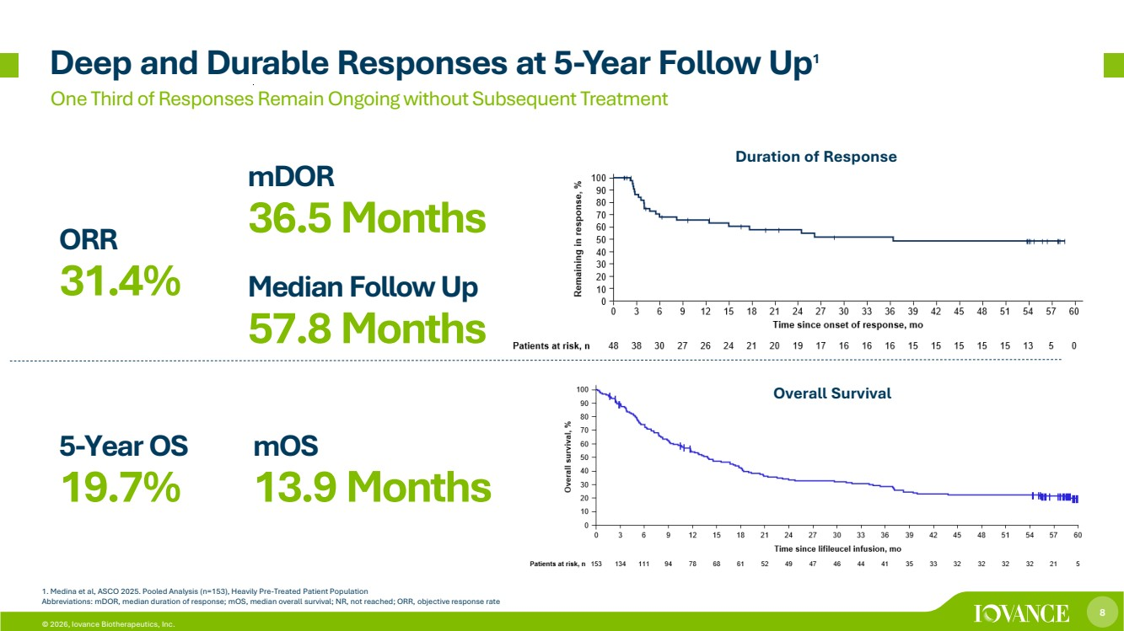 | 8 © 2026, Iovance Biotherapeutics, Inc. One Third of Responses Remain Ongoing without Subsequent Treatment 5-Year OS 19.7% mDOR 36.5 Months ORR 31.4% mOS 13.9 Months 1. Medina et al, ASCO 2025. Pooled Analysis (n=153), Heavily Pre-Treated Patient Population Abbreviations: mDOR, median duration of response; mOS, median overall survival; NR, not reached; ORR, objective response rate Duration of Response Overall Survival Deep and Durable Responses at 5-Year Follow Up1 Median Follow Up 57.8 Months
 | 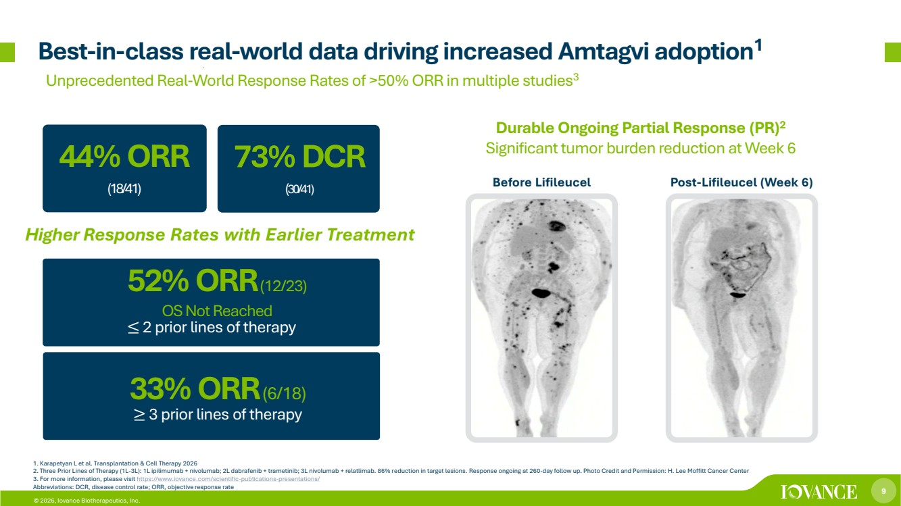 | 9 © 2026, Iovance Biotherapeutics, Inc. 52% ORR(12/23) OS Not Reached Best-in-class real-world data driving increased Amtagvi adoption1 1. Karapetyan L et al. Transplantation & Cell Therapy 2026 2. Three Prior Lines of Therapy (1L-3L): 1L ipilimumab + nivolumab; 2L dabrafenib + trametinib; 3L nivolumab + relatlimab. 86% reduction in target lesions. Response ongoing at 260-day follow up. Photo Credit and Permission: H. Lee Moffitt Cancer Center 3. For more information, please visit https://www.iovance.com/scientific-publications-presentations/ Abbreviations: DCR, disease control rate; ORR, objective response rate 44% ORR (18/41) 33% ORR(6/18) Before Lifileucel Post-Lifileucel (Week 6) Durable Ongoing Partial Response (PR)2 Significanttumor burden reduction at Week 6 ≤ 2 prior lines of therapy ≥ 3 prior lines of therapy Unprecedented Real-World Response Rates of >50% ORR in multiple studies3 73% DCR (30/41) Higher Response Rates with Earlier Treatment
 | 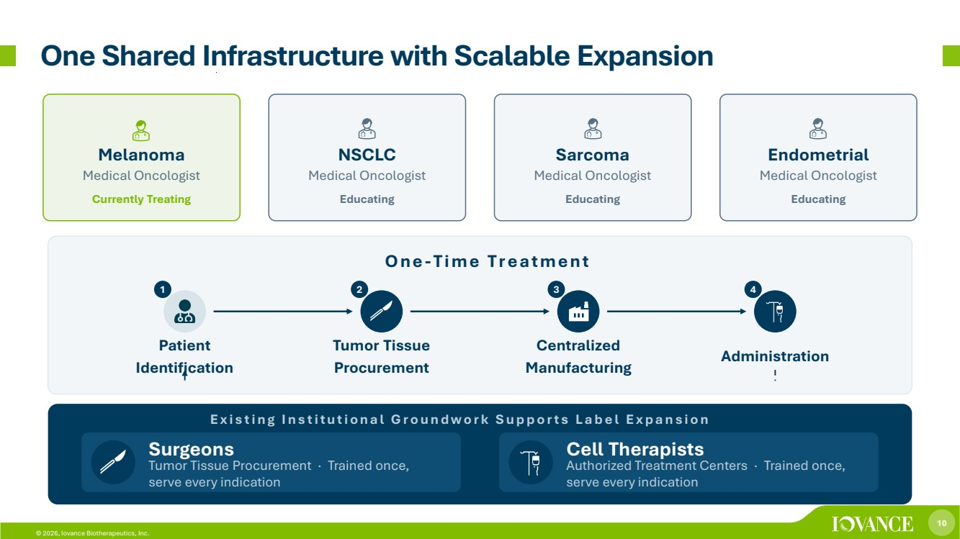 | 10 © 2026, Iovance Biotherapeutics, Inc. One Shared Infrastructure with Scalable Expansion Melanoma Medical Oncologist Currently Treating NSCLC Medical Oncologist Educating Sarcoma Medical Oncologist Educating Endometrial Medical Oncologist Educating One-Time Treatment 11 Patient Identification 22 Tumor Tissue Procurement 33 Centralized Manufacturing 44 Administration E x i s t i n g I n s t i t u t i o n a l G r o u n d w o r k S u p p o r t s L a b e l E x p a n s i o n Surgeons Tumor Tissue Procurement · Trained once, serve every indication Cell Therapists Authorized Treatment Centers · Trained once, serve every indication
 | 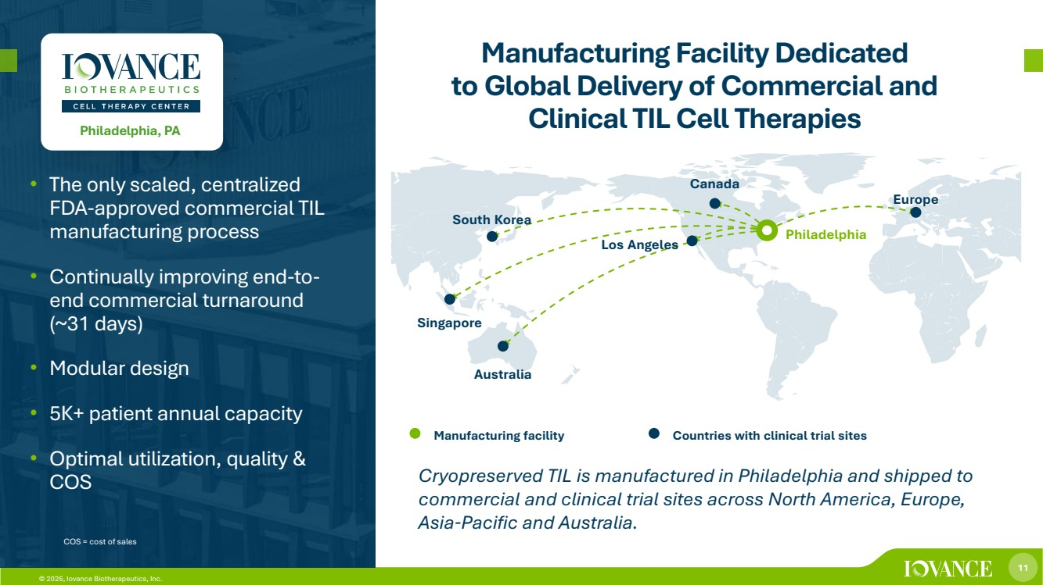 | 11 © 2026, Iovance Biotherapeutics, Inc. • The only scaled, centralized FDA-approved commercial TIL manufacturing process • Continually improving end-to-end commercial turnaround (~31 days) • Modular design • 5K+ patient annual capacity • Optimal utilization, quality & COS Manufacturing Facility Dedicated to Global Delivery of Commercial and Clinical TIL Cell Therapies COS = cost of sales Philadelphia, PA Manufacturing facility Countries with clinical trial sites Cryopreserved TIL is manufactured in Philadelphia and shipped to commercial and clinical trial sites across North America, Europe, Asia-Pacific and Australia. Philadelphia Los Angeles Canada Europe South Korea Singapore Australia
 | 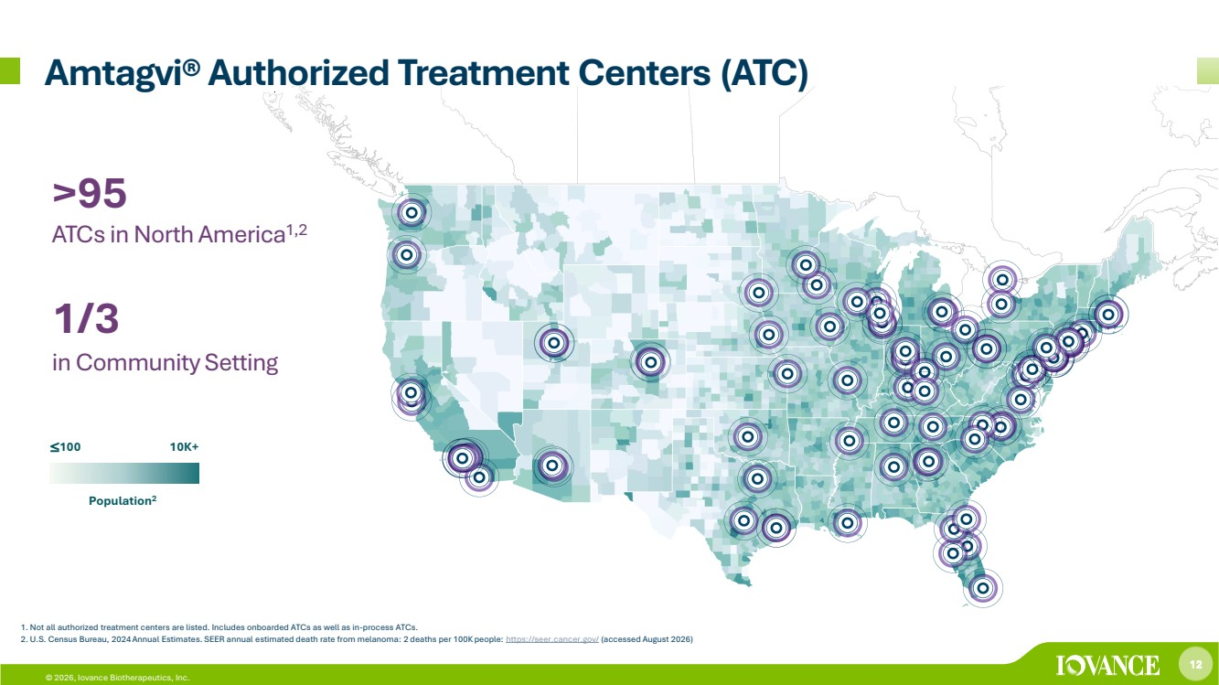 | 12 © 2026, Iovance Biotherapeutics, Inc. >95 ATCs in North America1,2 1/3 in Community Setting ≤100 10K+ Population2 1. Not all authorized treatment centers are listed. Includes onboarded ATCs as well as in-process ATCs. 2. U.S. Census Bureau, 2024 Annual Estimates. SEER annual estimated death rate from melanoma: 2 deaths per 100K people: https://seer.cancer.gov/ (accessed August 2026) Amtagvi® Authorized Treatment Centers (ATC)
 | 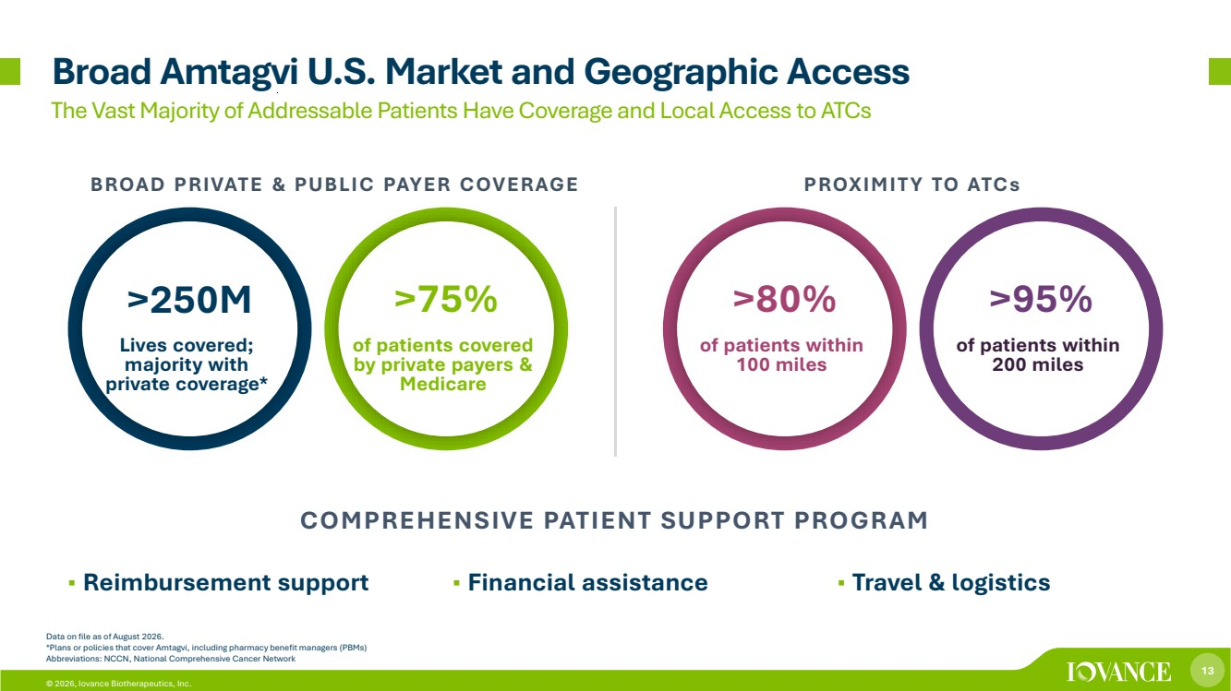 | 13 © 2026, Iovance Biotherapeutics, Inc. Broad Amtagvi U.S. Market and Geographic Access Data on file as of August 2026. *Plans or policies that cover Amtagvi, including pharmacy benefit managers (PBMs) Abbreviations: NCCN, National Comprehensive Cancer Network Lives covered; majority with private coverage* >250M >75% >80% of patients covered by private payers & Medicare of patients within 100 miles of patients within 200 miles BROAD PRIVATE & PUBLIC PAYER COVERAGE PROXIMITY TO ATCs >95% The Vast Majority of Addressable Patients Have Coverage and Local Access to ATCs COMPREHENSIVE PATIENT SUPPORT PROGRAM ▪ Reimbursement support ▪ Financial assistance ▪ Travel & logistics
 | 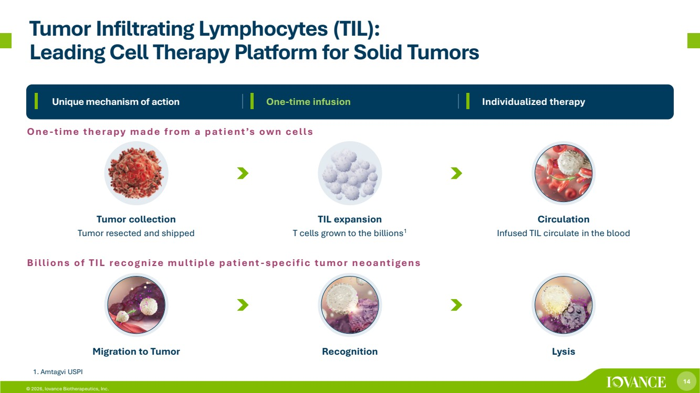 | 14 © 2026, Iovance Biotherapeutics, Inc. Tumor Infiltrating Lymphocytes (TIL): Leading Cell Therapy Platform for Solid Tumors 1. Amtagvi USPI Circulation Infused TIL circulate in the blood Migration to Tumor Recognition Lysis TIL expansion T cells grown to the billions1 Tumor collection Tumor resected and shipped Individualized therapy One-time therapy made from a patient’s own cells Billions of TIL recognize multiple patient-specific tumor neoantigens Unique mechanism of action One-time infusion
 | 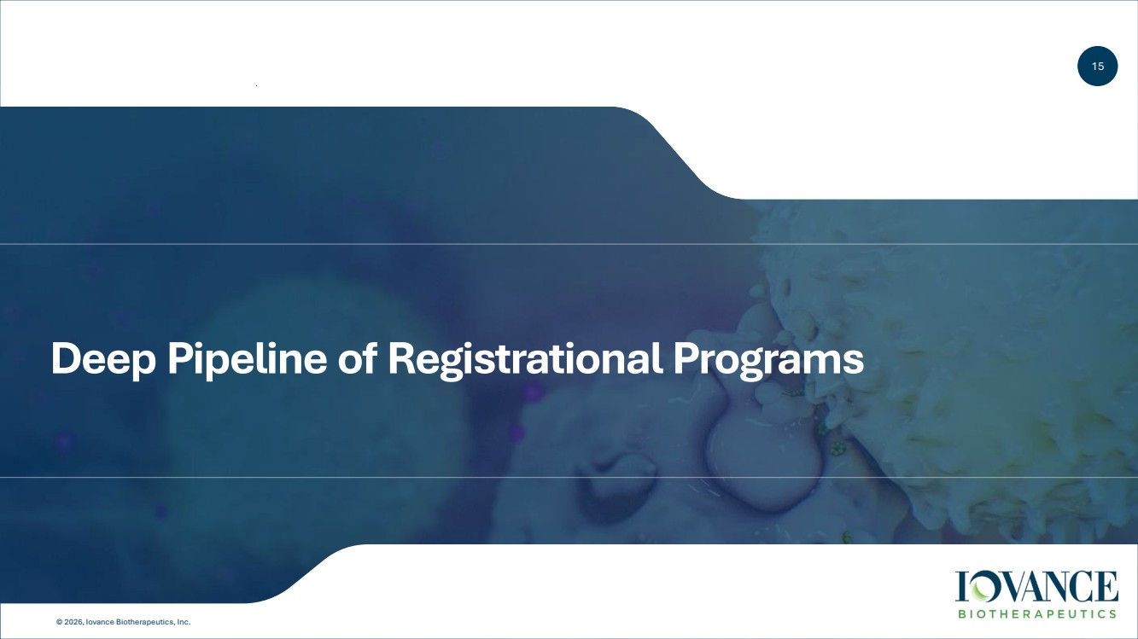 | 15 © 2026, Iovance Biotherapeutics, Inc. Deep Pipeline of Registrational Programs
 | 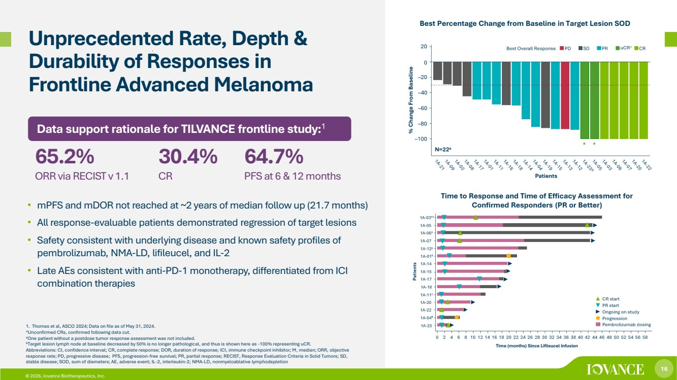 | 16 © 2026, Iovance Biotherapeutics, Inc. Unprecedented Rate, Depth & Durability of Responses in Frontline Advanced Melanoma • mPFS and mDOR not reached at ~2 years of median follow up (21.7 months) • All response-evaluable patients demonstrated regression of target lesions • Safety consistent with underlying disease and known safety profiles of pembrolizumab, NMA-LD, lifileucel, and IL-2 • Late AEs consistent with anti-PD-1 monotherapy, differentiated from ICI combination therapies 1. Thomas et al, ASCO 2024; Data on file as of May 31, 2024. *Unconfirmed CRs, confirmed following data cut. aOne patient without a postdose tumor response assessment was not included. bTarget lesion lymph node at baseline decreased by 50% is no longer pathological, and thus is shown here as -100% representing uCR. Abbreviations: CI, confidence interval; CR, complete response; DOR, duration of response; ICI, immune checkpoint inhibitor; M, median; ORR, objective response rate; PD, progressive disease; PFS, progression-free survival; PR, partial response; RECIST, Response Evaluation Criteria in Solid Tumors; SD, stable disease; SOD, sum of diameters; AE, adverse event; IL-2, interleukin-2; NMA-LD, nonmyeloablative lymphodepletion Data support rationale for TILVANCE frontline study:1 65.2% ORR via RECIST v 1.1 30.4% CR 64.7% PFS at 6 & 12 months Best Percentage Change from Baseline in Target Lesion SOD Time to Response and Time of Efficacy Assessment for Confirmed Responders (PR or Better)
 | 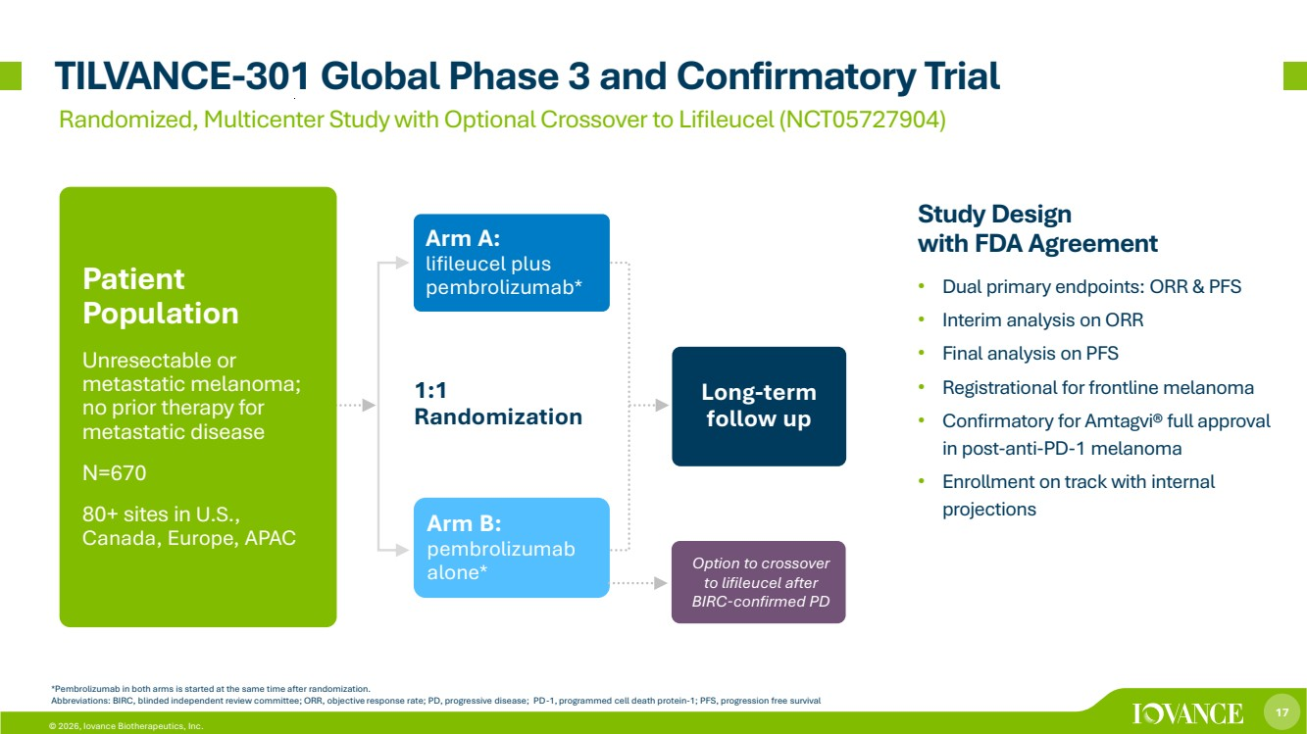 | 17 © 2026, Iovance Biotherapeutics, Inc. Option to crossover to lifileucel after BIRC-confirmed PD 1:1 Randomization TILVANCE-301 Global Phase 3 and Confirmatory Trial *Pembrolizumab in both arms is started at the same time after randomization. Abbreviations: BIRC, blinded independent review committee; ORR, objective response rate; PD, progressive disease; PD-1, programmed cell death protein-1; PFS, progression free survival Arm A: lifileucel plus pembrolizumab* Long-term follow up Patient Population Unresectable or metastatic melanoma; no prior therapy for metastatic disease N=670 80+ sites in U.S., Canada, Europe, APAC Arm B: pembrolizumab alone* Study Design with FDA Agreement • Dual primary endpoints: ORR & PFS • Interim analysis on ORR • Final analysis on PFS • Registrational for frontline melanoma • Confirmatory for Amtagvi® full approval in post-anti-PD-1 melanoma • Enrollment on track with internal projections Randomized, Multicenter Study with Optional Crossover to Lifileucel (NCT05727904)
 | 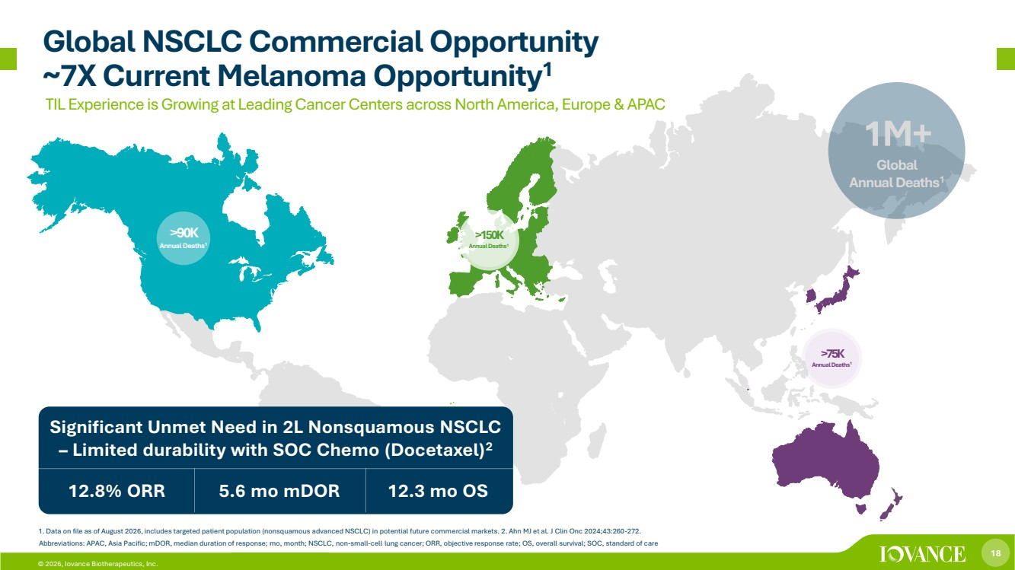 | 18 © 2026, Iovance Biotherapeutics, Inc. 1M+ Global Annual Deaths1 Significant Unmet Need in 2L Nonsquamous NSCLC – Limited durability with SOC Chemo (Docetaxel)2 12.8% ORR 5.6 mo mDOR 12.3 mo OS >90K Annual Deaths1 1. Data on file as of August 2026, includes targeted patient population (nonsquamous advanced NSCLC) in potential future commercial markets. 2. Ahn MJ et al. J Clin Onc 2024;43:260-272. Abbreviations: APAC, Asia Pacific; mDOR, median duration of response; mo, month; NSCLC, non-small-cell lung cancer; ORR, objective response rate; OS, overall survival; SOC, standard of care >150K Annual Deaths1 >75K Annual Deaths1 TIL Experience is Growing at Leading Cancer Centers across North America, Europe & APAC Global NSCLC Commercial Opportunity ~7X Current Melanoma Opportunity1
 | 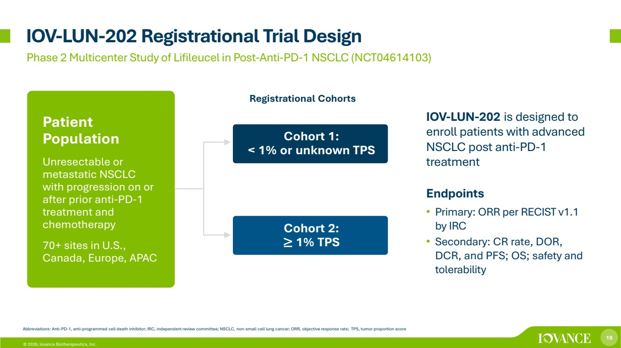 | 19 © 2026, Iovance Biotherapeutics, Inc. IOV-LUN-202 Registrational Trial Design Phase 2 Multicenter Study of Lifileucel in Post-Anti-PD-1 NSCLC (NCT04614103) Abbreviations: Anti-PD-1, anti-programmed cell death inhibitor; IRC, independent review committee; NSCLC, non-small cell lung cancer; ORR, objective response rate; TPS, tumor proportion score Iovance TIL Therapy Lifileucel in NSCLC IOV-LUN-202 is designed to enroll patients with advanced NSCLC post anti-PD-1 treatment Endpoints • Primary: ORR per RECIST v1.1 by IRC • Secondary: CR rate, DOR, DCR, and PFS; OS; safety and tolerability Patient Population Unresectable or metastatic NSCLC with progression on or after prior anti-PD-1 treatment and chemotherapy 70+ sites in U.S., Canada, Europe, APAC Cohort 1: < 1% or unknown TPS Cohort 2: ≥ 1% TPS Registrational Cohorts
 | 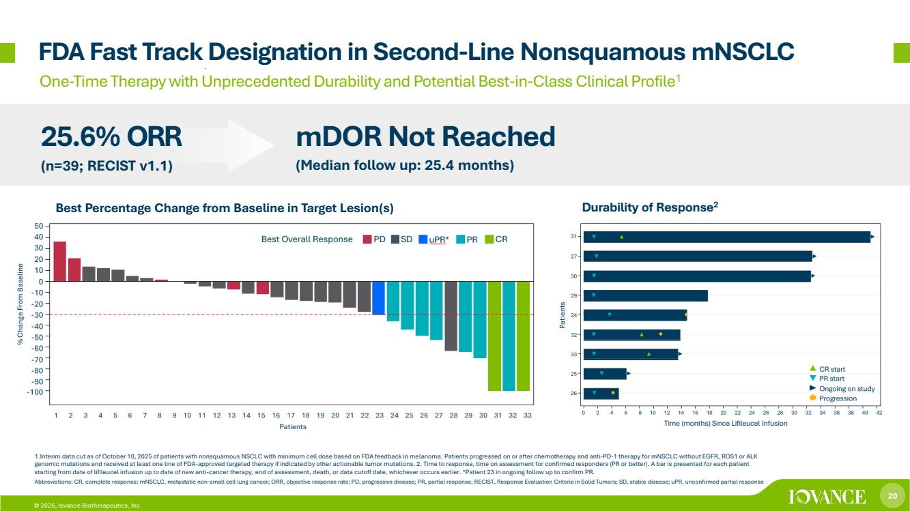 | 20 © 2026, Iovance Biotherapeutics, Inc. FDA Fast Track Designation in Second-Line Nonsquamous mNSCLC 1.Interim data cut as of October 10, 2025 of patients with nonsquamous NSCLC with minimum cell dose based on FDA feedback in melanoma. Patients progressed on or after chemotherapy and anti-PD-1 therapy for mNSCLC without EGFR, ROS1 or ALK genomic mutations and received at least one line of FDA-approved targeted therapy if indicated by other actionable tumor mutations. 2. Time to response, time on assessment for confirmed responders (PR or better). A bar is presented for each patient starting from date of lifileucel infusion up to date of new anti-cancer therapy, end of assessment, death, or data cutoff date, whichever occurs earlier. *Patient 23 in ongoing follow up to confirm PR. Abbreviations: CR, complete response; mNSCLC, metastatic non-small cell lung cancer; ORR, objective response rate; PD, progressive disease; PR, partial response; RECIST, Response Evaluation Criteria in Solid Tumors; SD, stable disease; uPR, unconfirmed partial response One-Time Therapy with Unprecedented Durability and Potential Best-in-Class Clinical Profile1 25.6% ORR (n=39; RECIST v1.1) mDOR Not Reached (Median follow up: 25.4 months) Patients Time (months) Since Lifileucel Infusion % Change From Baseline Durability of Response2 Patients Best Percentage Change from Baseline in Target Lesion(s)
 | 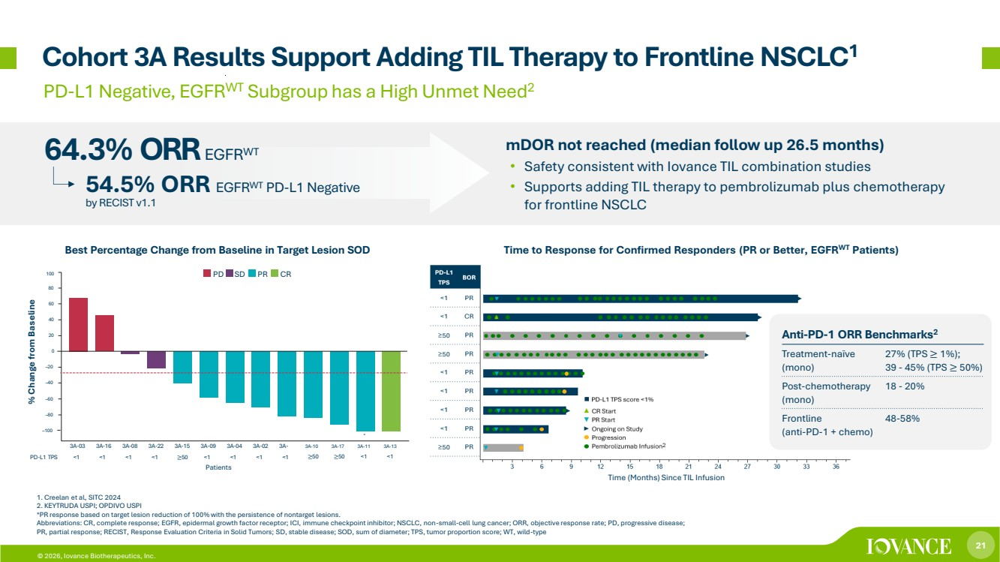 | 21 © 2026, Iovance Biotherapeutics, Inc. Cohort 3A Results Support Adding TIL Therapy to Frontline NSCLC1 % Change from Baseline Time (Months) Since TIL Infusion PD-L1 Negative, EGFRWT Subgroup has a High Unmet Need2 Best Percentage Change from Baseline in Target Lesion SOD 64.3% ORR EGFRWT Time to Response for Confirmed Responders (PR or Better, EGFRWT Patients) mDOR not reached (median follow up 26.5 months) • Safety consistent with Iovance TIL combination studies • Supports adding TIL therapy to pembrolizumab plus chemotherapy for frontline NSCLC 1. Creelan et al, SITC 2024 2. KEYTRUDA USPI; OPDIVO USPI *PR response based on target lesion reduction of 100% with the persistence of nontarget lesions. Abbreviations: CR, complete response; EGFR, epidermal growth factor receptor; ICI, immune checkpoint inhibitor; NSCLC, non-small-cell lung cancer; ORR, objective response rate; PD, progressive disease; PR, partial response; RECIST, Response Evaluation Criteria in Solid Tumors; SD, stable disease; SOD, sum of diameter; TPS, tumor proportion score; WT, wild-type 54.5% ORR EGFRWT PD-L1 Negative by RECIST v1.1 Anti-PD-1 ORR Benchmarks2 Treatment-naïve (mono) 27% (TPS ≥ 1%); 39 - 45% (TPS ≥ 50%) Post-chemotherapy (mono) 18 - 20% Frontline (anti-PD-1 + chemo) 48-58% 2 Patients 60 40 20 0 –20 –40 –60 –80 –100 a 3A-03 3A-16 3A-08 3A-22 3A-15 3A-09 3A-04 3A-02 3A-PD-L1 TPS <1 <1 <1 <1 ≥50 <1 <1 <1 <1 3A-10 ≥50 3A-17 ≥50 3A-11 <1 3A-13 <1 80 100 PD SD PR CR
 | 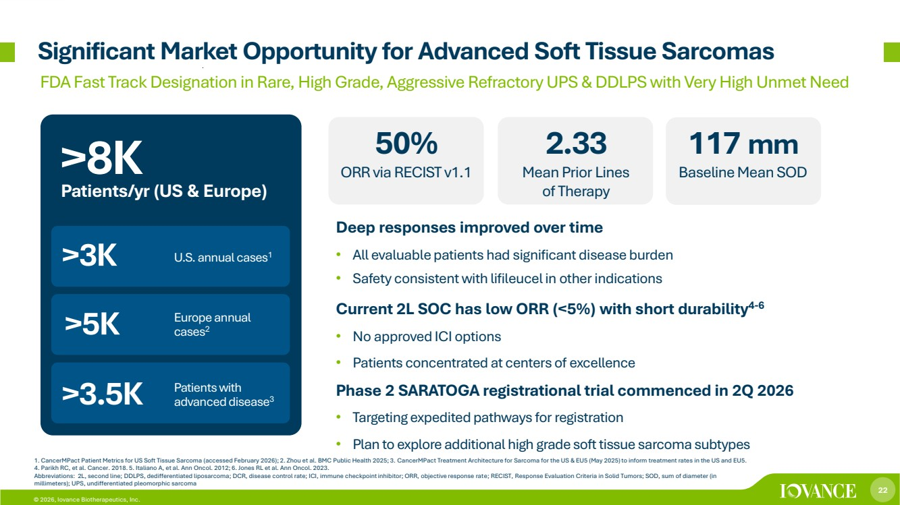 | 22 © 2026, Iovance Biotherapeutics, Inc. 1. CancerMPact Patient Metrics for US Soft Tissue Sarcoma (accessed February 2026); 2. Zhou et al. BMC Public Health 2025; 3. CancerMPact Treatment Architecture for Sarcoma for the US & EU5 (May 2025) to inform treatment rates in the US and EU5. 4. Parikh RC, et al. Cancer. 2018. 5. Italiano A, et al. Ann Oncol. 2012; 6. Jones RL et al. Ann Oncol. 2023. Abbreviations: 2L, second line; DDLPS, dedifferentiated liposarcoma; DCR, disease control rate; ICI, immune checkpoint inhibitor; ORR, objective response rate; RECIST, Response Evaluation Criteria in Solid Tumors; SOD, sum of diameter (in millimeters); UPS, undifferentiated pleomorphic sarcoma Significant Market Opportunity for Advanced Soft Tissue Sarcomas FDA Fast Track Designation in Rare, High Grade, Aggressive RefractoryUPS & DDLPS with Very HighUnmet Need Deep responses improved over time • All evaluable patients had significant disease burden • Safety consistent with lifileucel in other indications Current 2L SOC has low ORR (<5%) with short durability4-6 • No approved ICI options • Patients concentrated at centers of excellence Phase 2 SARATOGA registrational trial commenced in 2Q 2026 • Targeting expedited pathways for registration • Plan to explore additional high grade soft tissue sarcoma subtypes >3K >5K U.S. annual cases1 Patients with advanced disease3 Europe annual cases2 >3.5K >8K Patients/yr (US & Europe) 50% ORR via RECIST v1.1 2.33 Mean Prior Lines of Therapy 117 mm Baseline Mean SOD
 | 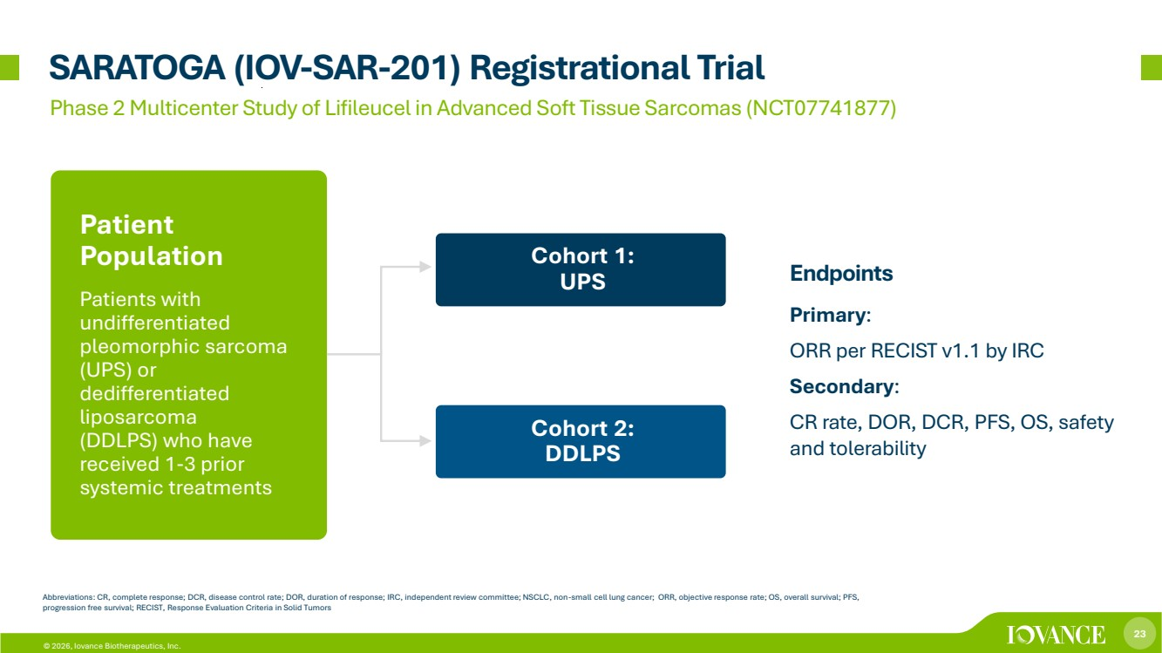 | 23 © 2026, Iovance Biotherapeutics, Inc. SARATOGA (IOV-SAR-201) Registrational Trial Phase 2 Multicenter Study of Lifileucel in Advanced Soft Tissue Sarcomas (NCT07741877) Abbreviations: CR, complete response; DCR, disease control rate; DOR, duration of response; IRC, independent review committee; NSCLC, non-small cell lung cancer; ORR, objective response rate; OS, overall survival; PFS, progression free survival; RECIST, Response Evaluation Criteria in Solid Tumors Endpoints Primary: ORR per RECIST v1.1 by IRC Secondary: CR rate, DOR, DCR, PFS, OS, safety and tolerability Patient Population Patients with undifferentiated pleomorphic sarcoma (UPS) or dedifferentiated liposarcoma (DDLPS) who have received 1-3 prior systemic treatments Cohort 1: UPS Cohort 2: DDLPS
 | 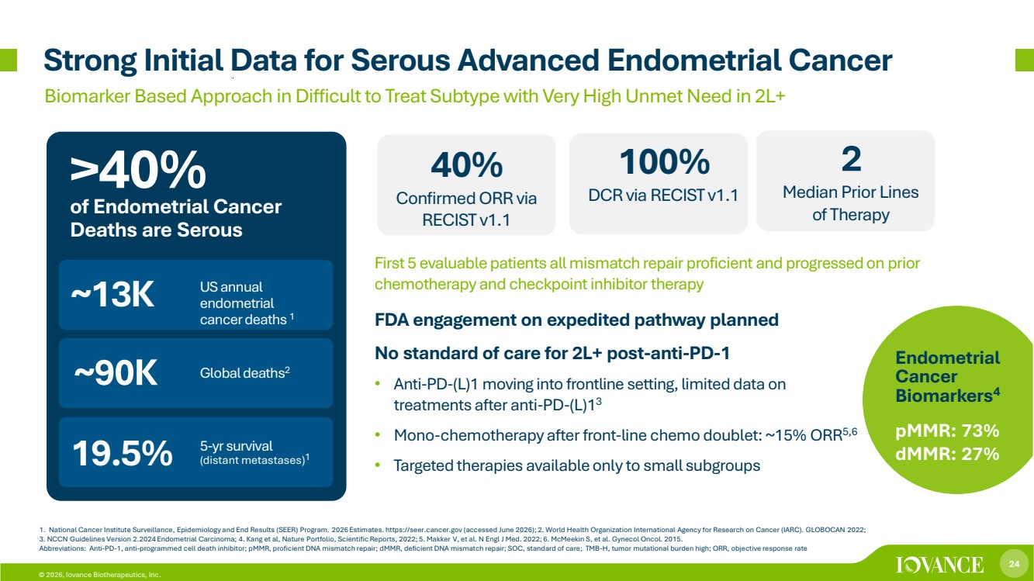 | 24 © 2026, Iovance Biotherapeutics, Inc. 1. National Cancer Institute Surveillance, Epidemiology and End Results (SEER) Program. 2026 Estimates. https://seer.cancer.gov (accessed June 2026); 2. World Health Organization International Agency for Research on Cancer (IARC). GLOBOCAN 2022; 3. NCCN Guidelines Version 2.2024 Endometrial Carcinoma; 4. Kang et al, Nature Portfolio, Scientific Reports, 2022; 5. Makker V, et al. N Engl J Med. 2022; 6. McMeekin S, et al. Gynecol Oncol. 2015. Abbreviations: Anti-PD-1, anti-programmed cell death inhibitor; pMMR, proficient DNA mismatch repair; dMMR, deficient DNA mismatch repair; SOC, standard of care; TMB-H, tumor mutational burden high; ORR, objective response rate Strong Initial Data for Serous Advanced Endometrial Cancer Biomarker Based Approach in Difficult to Treat Subtype with Very High Unmet Need in 2L+ FDA engagement on expedited pathway planned No standard of care for 2L+ post-anti-PD-1 • Anti-PD-(L)1 moving into frontline setting, limited data on treatments after anti-PD-(L)13 • Mono-chemotherapy after front-line chemo doublet: ~15% ORR5,6 • Targeted therapies available only to small subgroups ~13K ~90K US annual endometrial cancer deaths 1 5-yr survival (distant metastases) 1 Global deaths2 19.5% Endometrial Cancer Biomarkers4 pMMR: 73% dMMR: 27% >40% of Endometrial Cancer Deaths are Serous 40% Confirmed ORR via RECIST v1.1 100% DCR via RECIST v1.1 2 Median Prior Lines of Therapy First 5 evaluable patients all mismatch repair proficient and progressedon prior chemotherapy and checkpoint inhibitor therapy
 | 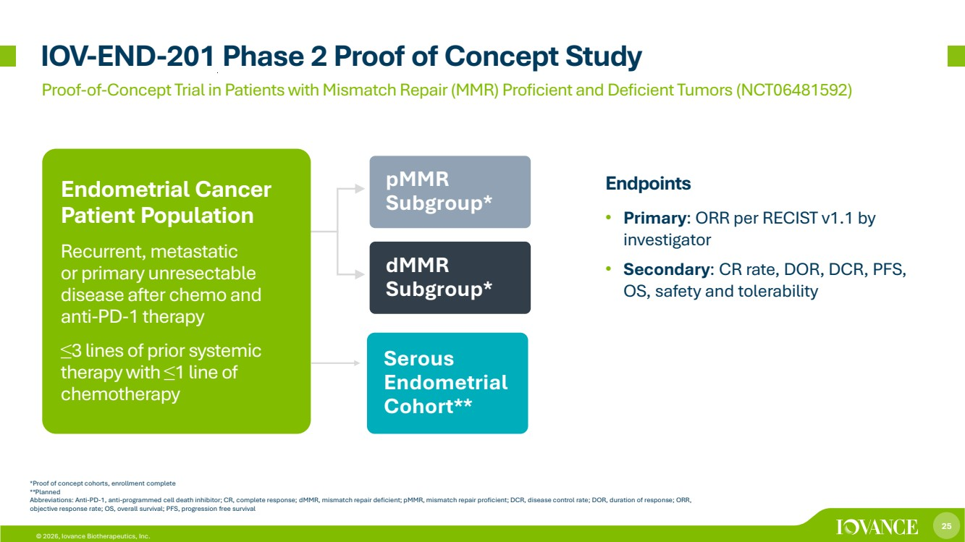 | 25 © 2026, Iovance Biotherapeutics, Inc. pMMR Subgroup* dMMR Subgroup* Endpoints • Primary: ORR per RECIST v1.1 by investigator • Secondary: CR rate, DOR, DCR, PFS, OS, safety and tolerability IOV-END-201 Phase 2 Proof of Concept Study Endometrial Cancer Patient Population Recurrent, metastatic or primary unresectable disease after chemo and anti-PD-1 therapy ≤3 lines of prior systemic therapy with ≤1 line of chemotherapy *Proof of concept cohorts, enrollment complete **Planned Abbreviations: Anti-PD-1, anti-programmed cell death inhibitor; CR, complete response; dMMR, mismatch repair deficient; pMMR, mismatch repair proficient; DCR, disease control rate; DOR, duration of response; ORR, objective response rate; OS, overall survival; PFS, progression free survival Proof-of-Concept Trial in Patients with Mismatch Repair (MMR) Proficient and Deficient Tumors (NCT06481592) Serous Endometrial Cohort**
 | 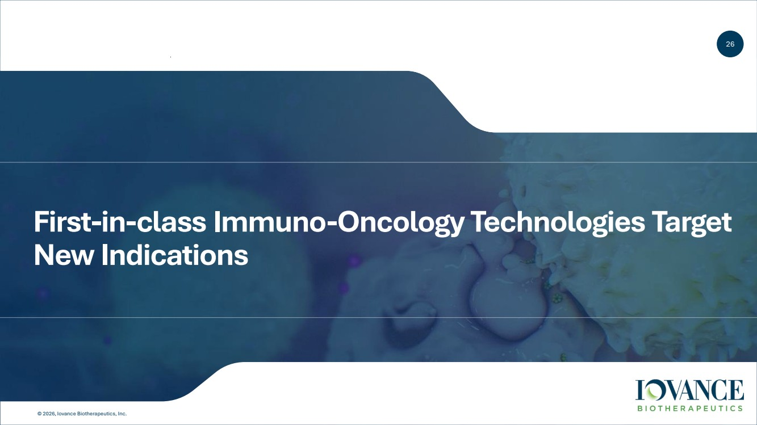 | 26 © 2026, Iovance Biotherapeutics, Inc. First-in-class Immuno-Oncology Technologies Target New Indications
 | 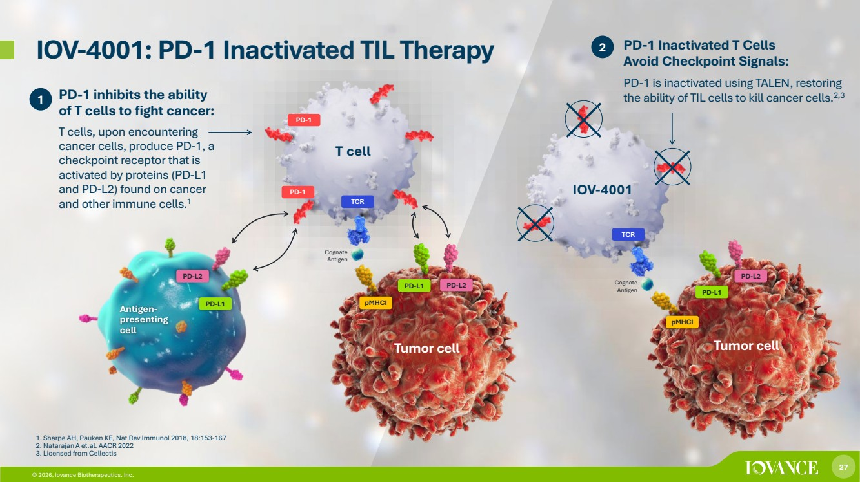 | 27 © 2026, Iovance Biotherapeutics, Inc. © 2026, Iovance Biotherapeutics, Inc. IOV-4001: PD-1 Inactivated TIL Therapy 2 T cell PD-1 PD-1 inhibits the ability of T cells to fight cancer: T cells, upon encountering cancer cells, produce PD-1, a checkpoint receptor that is activated by proteins (PD-L1 and PD-L2) found on cancer and other immune cells.1 PD-L2 PD-L1 PD-1 TCR pMHCI PD-L1 PD-L2 Tumor cell Antigen-presenting cell 1. Sharpe AH, Pauken KE, Nat Rev Immunol 2018, 18:153-167 2. Natarajan A et.al. AACR 2022 3. Licensed from Cellectis 1 IOV-4001 TCR pMHCI PD-L2 PD-L1 Tumor cell PD-1 Inactivated T Cells Avoid Checkpoint Signals: PD-1 is inactivated using TALEN, restoring the ability of TIL cells to kill cancer cells.2,3 Cognate Antigen Cognate Antigen
 | 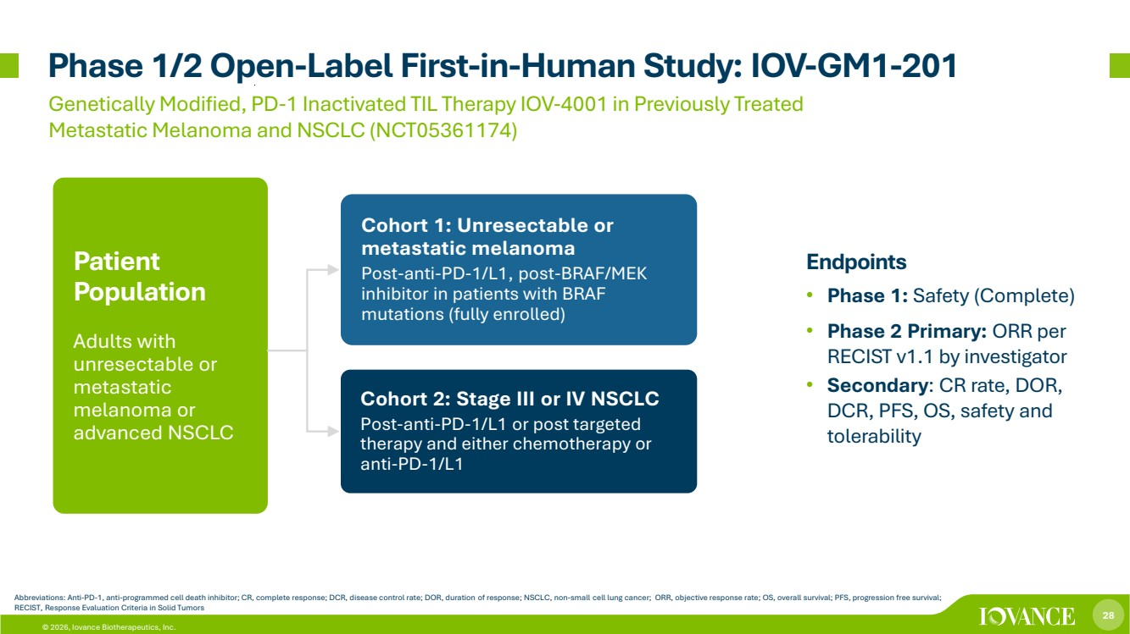 | 28 © 2026, Iovance Biotherapeutics, Inc. Phase 1/2 Open-Label First-in-Human Study: IOV-GM1-201 Endpoints • Phase 1: Safety (Complete) • Phase 2 Primary: ORR per RECIST v1.1 by investigator • Secondary: CR rate, DOR, DCR, PFS, OS, safety and tolerability Genetically Modified, PD-1 Inactivated TIL Therapy IOV-4001 in Previously Treated Metastatic Melanoma and NSCLC (NCT05361174) Cohort 1: Unresectable or metastatic melanoma Post-anti-PD-1/L1, post-BRAF/MEK inhibitor in patients with BRAF mutations (fully enrolled) Cohort 2: Stage III or IV NSCLC Post-anti-PD-1/L1 or post targeted therapy and either chemotherapy or anti-PD-1/L1 Patient Population Adults with unresectable or metastatic melanoma or advanced NSCLC Abbreviations: Anti-PD-1, anti-programmed cell death inhibitor; CR, complete response; DCR, disease control rate; DOR, duration of response; NSCLC, non-small cell lung cancer; ORR, objective response rate; OS, overall survival; PFS, progression free survival; RECIST, Response Evaluation Criteria in Solid Tumors
 | 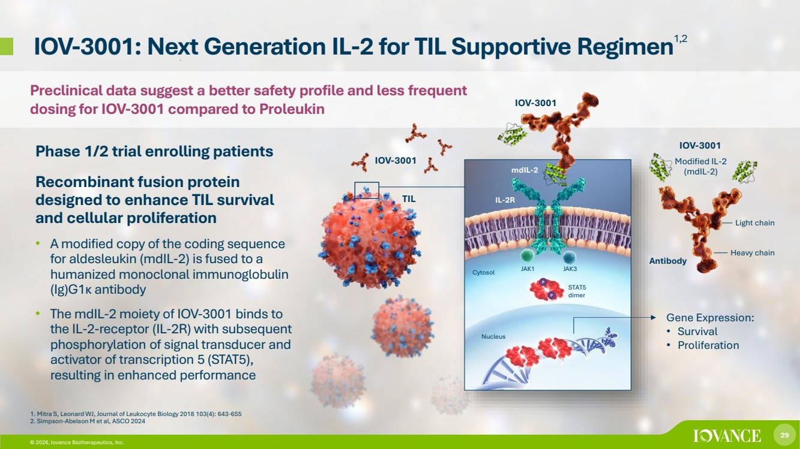 | 29 © 2026, Iovance Biotherapeutics, Inc. © 2026, Iovance Biotherapeutics, Inc. IOV-3001: Next Generation IL-2 for TIL Supportive Regimen1,2 Phase 1/2 trial enrolling patients Recombinant fusion protein designed to enhance TIL survival and cellular proliferation • A modified copy of the coding sequence for aldesleukin (mdIL-2) is fused to a humanized monoclonal immunoglobulin (Ig)G1κ antibody • The mdIL-2 moiety of IOV-3001 binds to the IL-2-receptor (IL-2R) with subsequent phosphorylation of signal transducer and activator of transcription 5 (STAT5), resulting in enhanced performance 1. Mitra S, Leonard WJ, Journal of Leukocyte Biology 2018 103(4): 643-655 2. Simpson-Abelson M et al, ASCO 2024 Gene Expression: • Survival • Proliferation mdIL-2 IL-2R JAK1 P JAK3 STAT5 dimer Cytosol Nucleus P IOV-3001 IOV-3001 Heavy chain Light chain IOV-3001 Modified IL-2 (mdIL-2) TIL Antibody Preclinical data suggest a better safety profile and less frequent dosing for IOV-3001 compared to Proleukin
 | 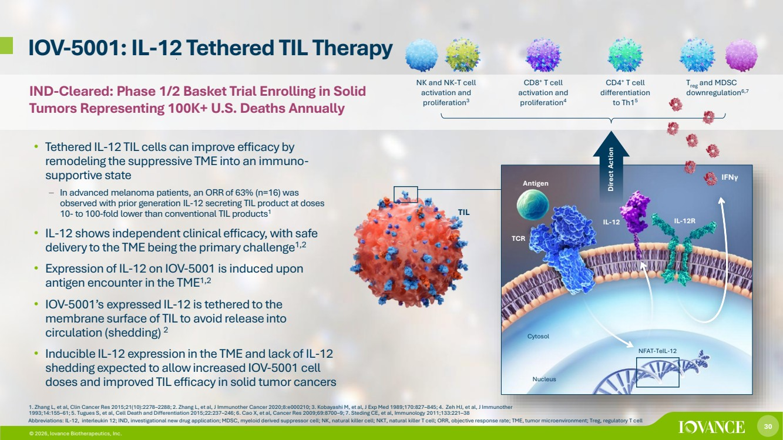 | 30 © 2026, Iovance Biotherapeutics, Inc. IOV-5001: IL-12 Tethered TIL Therapy 1. Zhang L, et al, Clin Cancer Res 2015;21(10):2278–2288; 2. Zhang L, et al, J Immunother Cancer 2020;8:e000210; 3. Kobayashi M, et al, J Exp Med 1989;170:827–845; 4. Zeh HJ, et al, J Immunother 1993;14:155–61; 5. Tugues S, et al, Cell Death and Differentiation 2015;22:237–246; 6. Cao X, et al, Cancer Res 2009;69:8700–9; 7. Steding CE, et al, Immunology 2011;133:221–38 • Tethered IL-12 TIL cells can improve efficacy by remodeling the suppressive TME into an immuno-supportive state – In advanced melanoma patients, an ORR of 63% (n=16) was observed with prior generation IL-12 secreting TIL product at doses 10- to 100-fold lower than conventional TIL products1 • IL-12 shows independent clinical efficacy, with safe delivery to the TME being the primary challenge1,2 • Expression of IL-12 on IOV-5001 is induced upon antigen encounter in the TME1,2 • IOV-5001’s expressed IL-12 is tethered to the membrane surface of TIL to avoid release into circulation (shedding) 2 • Inducible IL-12 expression in the TME and lack of IL-12 shedding expected to allow increased IOV-5001 cell doses and improved TIL efficacy in solid tumor cancers Abbreviations: IL-12, interleukin 12; IND, investigational new drug application; MDSC, myeloid derived suppressor cell; NK, natural killer cell; NKT, natural killer T cell; ORR, objective response rate; TME, tumor microenvironment; Treg, regulatory T cell NK and NK-T cell activation and proliferation3 CD8+ T cell activation and proliferation4 CD4+ T cell differentiation to Th15 Treg and MDSC downregulation6,7 30 Direct Action IFNγ Cytosol Nucleus TIL NFAT-TeIL-12 IL-12 IL-12R TCR Antigen © 2026, Iovance Biotherapeutics, Inc. IND-Cleared: Phase 1/2 Basket Trial Enrolling in Solid Tumors Representing 100K+ U.S. Deaths Annually
 | 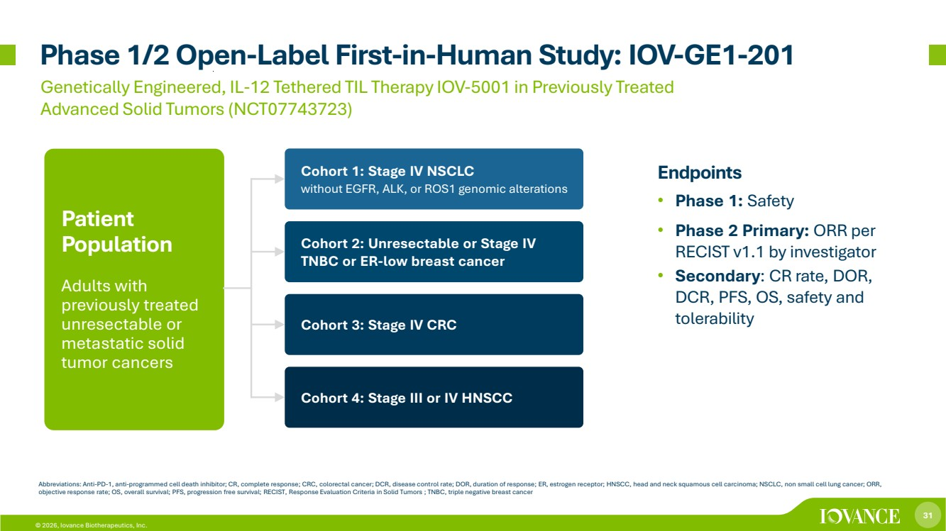 | 31 © 2026, Iovance Biotherapeutics, Inc. Phase 1/2 Open-Label First-in-Human Study: IOV-GE1-201 Endpoints • Phase 1: Safety • Phase 2 Primary: ORR per RECIST v1.1 by investigator • Secondary: CR rate, DOR, DCR, PFS, OS, safety and tolerability Genetically Engineered, IL-12 Tethered TIL Therapy IOV-5001 in Previously Treated Advanced Solid Tumors (NCT07743723) Cohort 1: Stage IV NSCLC without EGFR, ALK, or ROS1 genomic alterations Cohort 2: Unresectable or Stage IV TNBC or ER-low breast cancer Patient Population Adults with previously treated unresectable or metastatic solid tumor cancers Abbreviations: Anti-PD-1, anti-programmed cell death inhibitor; CR, complete response; CRC, colorectal cancer; DCR, disease control rate; DOR, duration of response; ER, estrogen receptor; HNSCC, head and neck squamous cell carcinoma; NSCLC, non small cell lung cancer; ORR, objective response rate; OS, overall survival; PFS, progression free survival; RECIST, Response Evaluation Criteria in Solid Tumors ; TNBC, triple negative breast cancer Cohort 3: Stage IV CRC Cohort 4: Stage III or IV HNSCC
 |  | 32 © 2026, Iovance Biotherapeutics, Inc. Financial Summary
 | 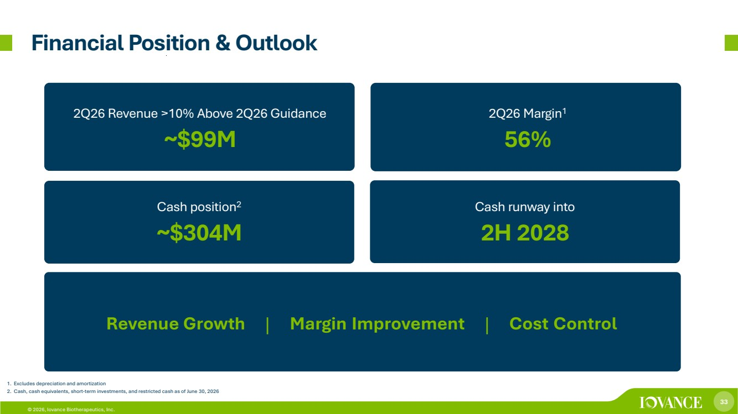 | 33 © 2026, Iovance Biotherapeutics, Inc. 1. Excludes depreciation and amortization 2. Cash, cash equivalents, short-term investments, and restricted cash as of June 30, 2026 Financial Position & Outlook Cash runway into 2H 2028 Revenue Growth | Margin Improvement | Cost Control Cash position2 ~$304M 2Q26 Margin1 56% 2Q26 Revenue >10% Above 2Q26 Guidance ~$99M
 |  | 34 © 2026, Iovance Biotherapeutics, Inc. © 2026, Iovance Biotherapeutics, Inc. Thank You

